## [1a] Add Trainer [POST] (Pass)

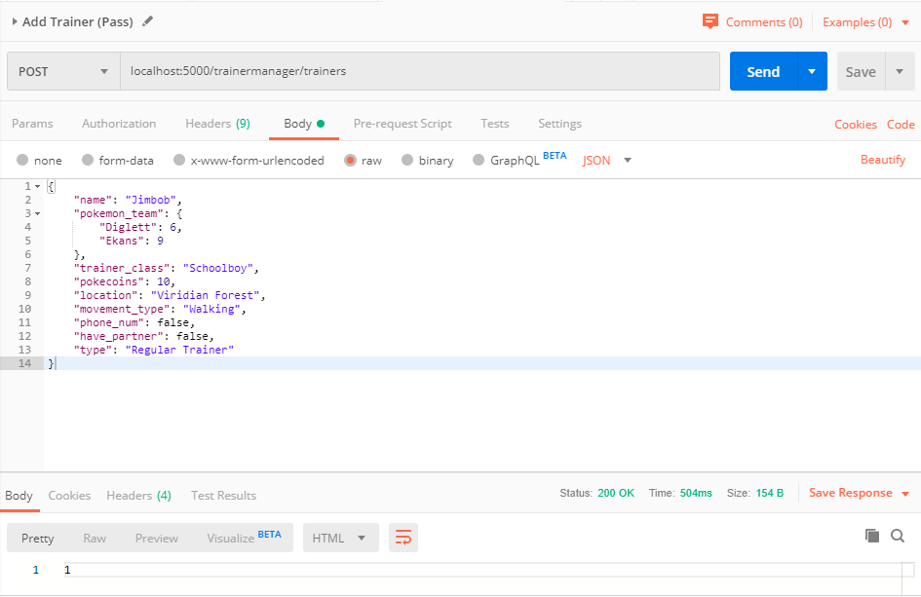

## [1b] Add Trainer [POST] (Fail)

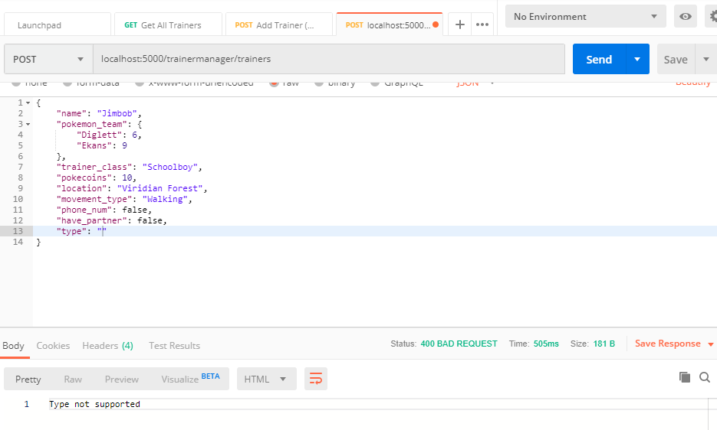

## [2a] Update Trainer by ID [PUT] (Pass)

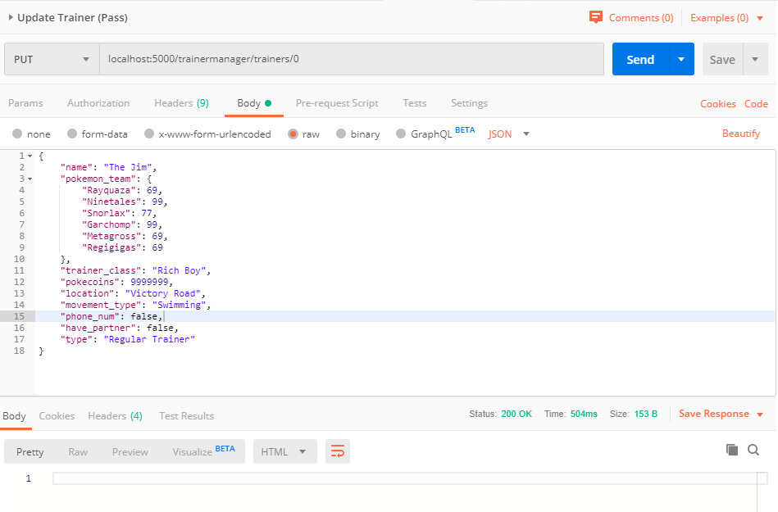

## [2b] Update Trainer by ID [PUT] (Fail)

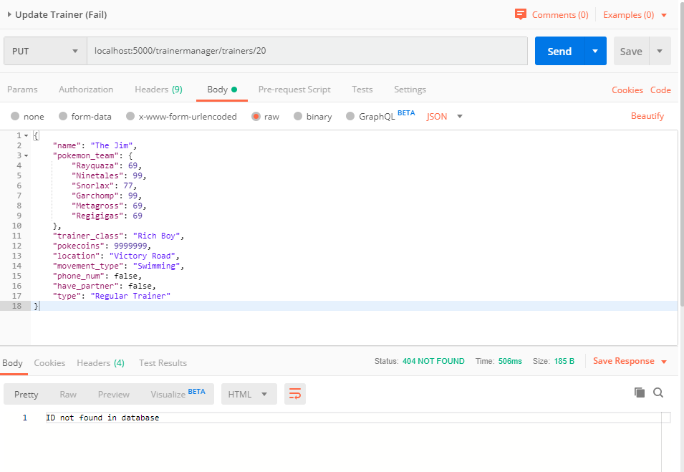

## [3a] Delete Trainer by ID [DELETE] (Pass)

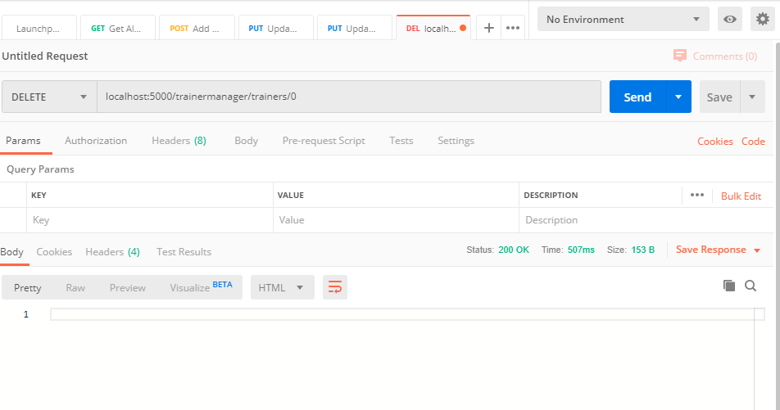

## [3b] Delete Trainer by ID [DELETE] (Fail)

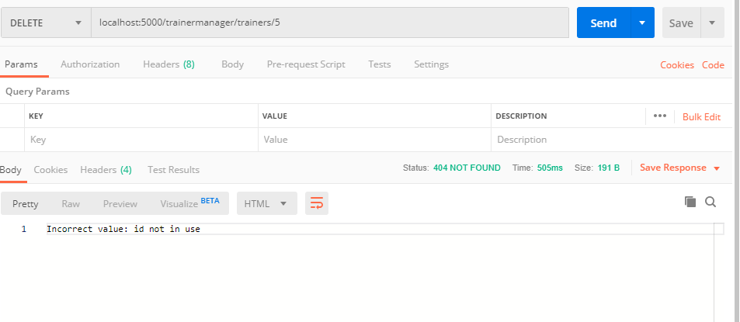

## [4a] Get Trainer by ID [GET] (Pass)

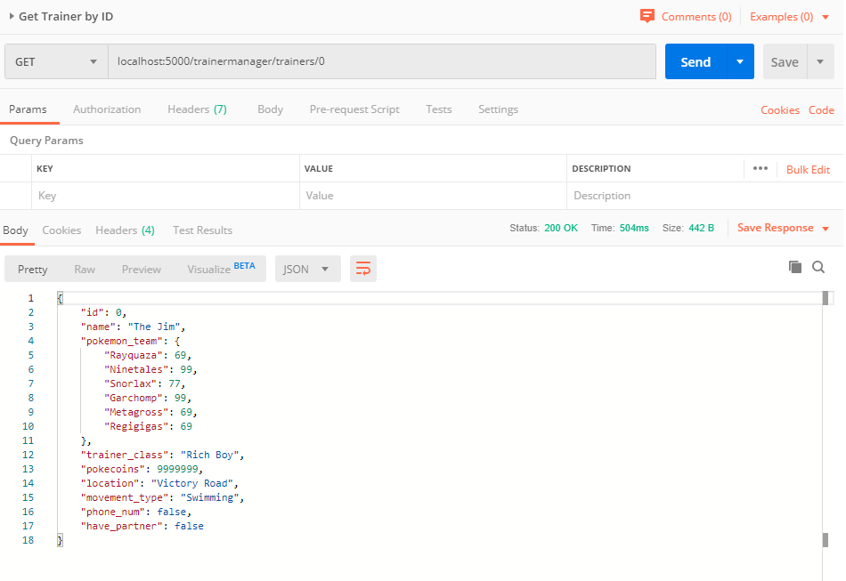

## [4b] Get Trainer by ID [GET] (Fail)

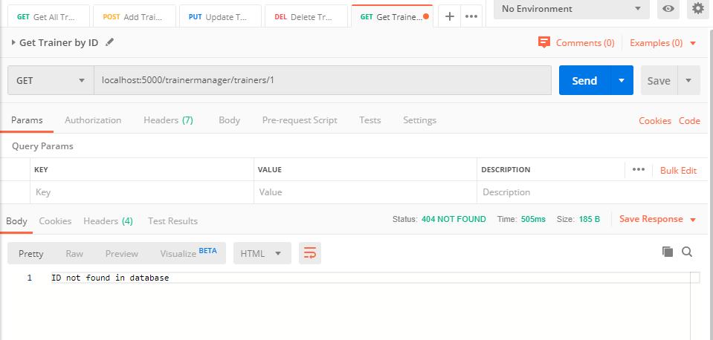

## [5a] Get All Trainers [GET] Empty

## 

## [5b] Get All Trainers [GET] More than Zero

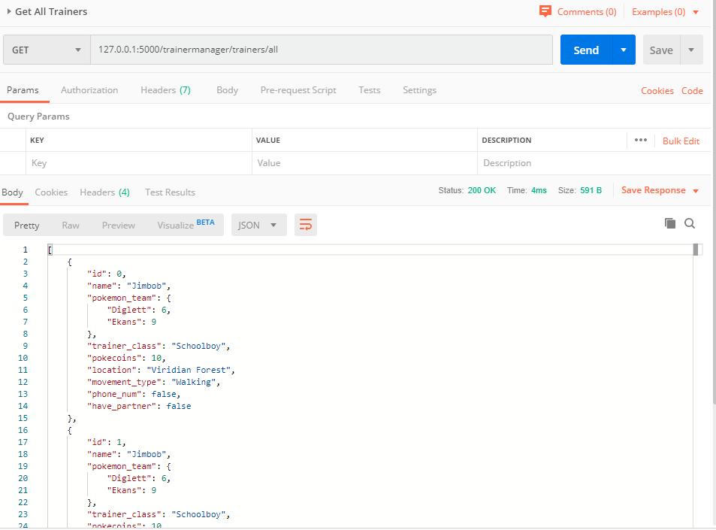

## [6a] Get All Trainers by Type [GET] (Pass)

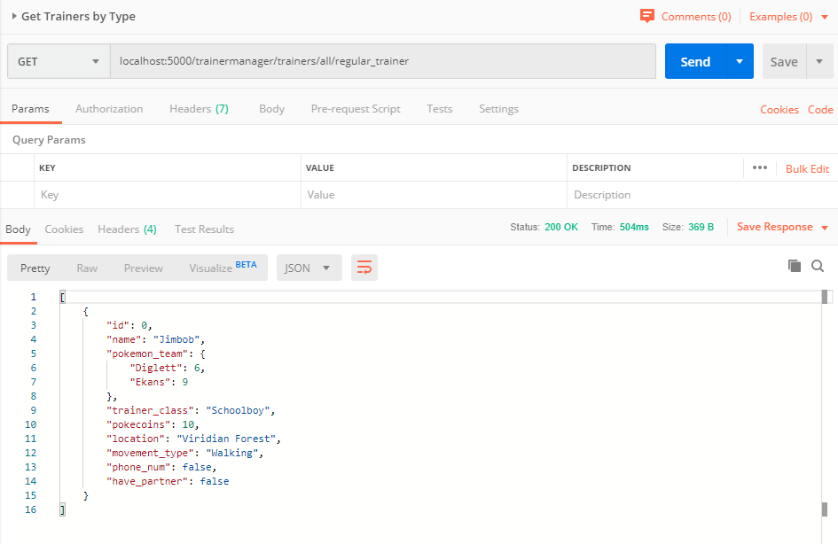

## [6b] Get All Trainers by Type [GET] (Fail)

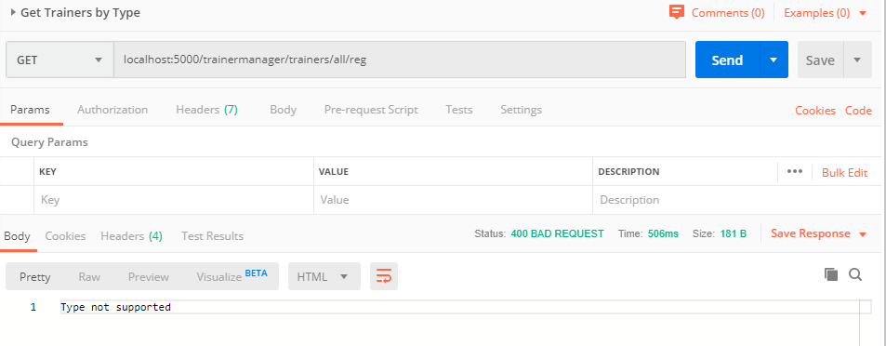

## [7] Get Trainer Manager Stats

